Aim: To create dashboard using power BI.

Lab Outcome:
•

Theory:
Q1. What is Power BI?
Power BI is a Microsoft business analytics tool that visualizes data and shares insights. It transforms data from various sources into interactive dashboards and reports for data-driven decision-making.
Q2. List Features of Power BI.
- Interactive dashboards
- Drag-and-drop report building
- Real-time analytics
- AI-powered insights
- Seamless integration with Excel, Azure, and other Microsoft services
Q3. What is the Power BI Dashboard?
A Power BI dashboard provides a consolidated, real-time view of key metrics. It enables quick decision-making through interactive visualizations, drill-down capabilities, and alerts, all accessible on web and mobile.
Q4. List Components of Power BI.
- Power Query (data extraction)
- Power Pivot (data modelling)
- Power View (visualizations)
- Power Map (geospatial visuals)
- Power BI Service (cloud sharing and collaboration)
Q5. List Advantages of Power BI.
- User-friendly
- Cost-effective
- Integrates with Microsoft ecosystem
- Supports real-time data
- Offers strong cloud and mobile access
- Includes AI capabilities for advanced analytics and forecasting
Q6. List Disadvantages of Power BI.
- Steep learning curve for DAX
- Limited customization in visuals
- Performance issues with very large datasets
- Advanced features require premium licenses, increasing cost for organizations
Data Set Used Excel:
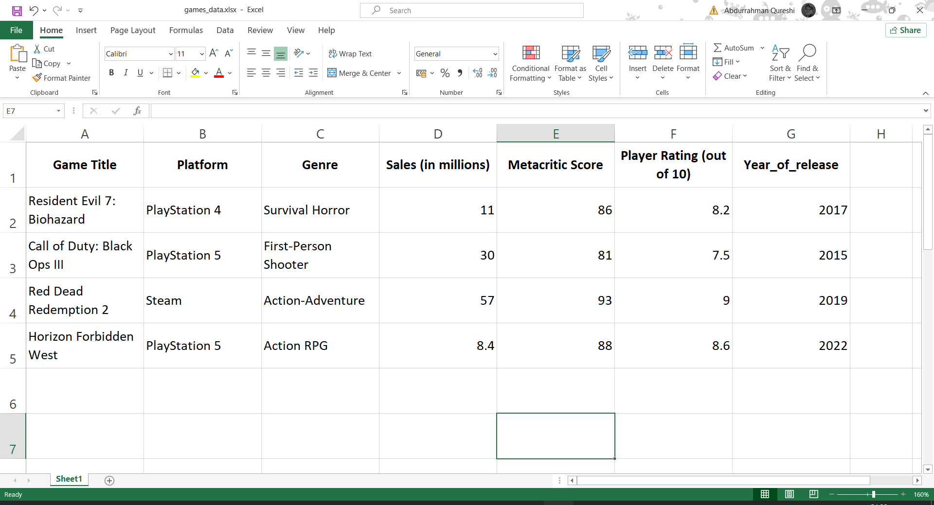

Donut Chart: To analyse Platform by Sum of Sales
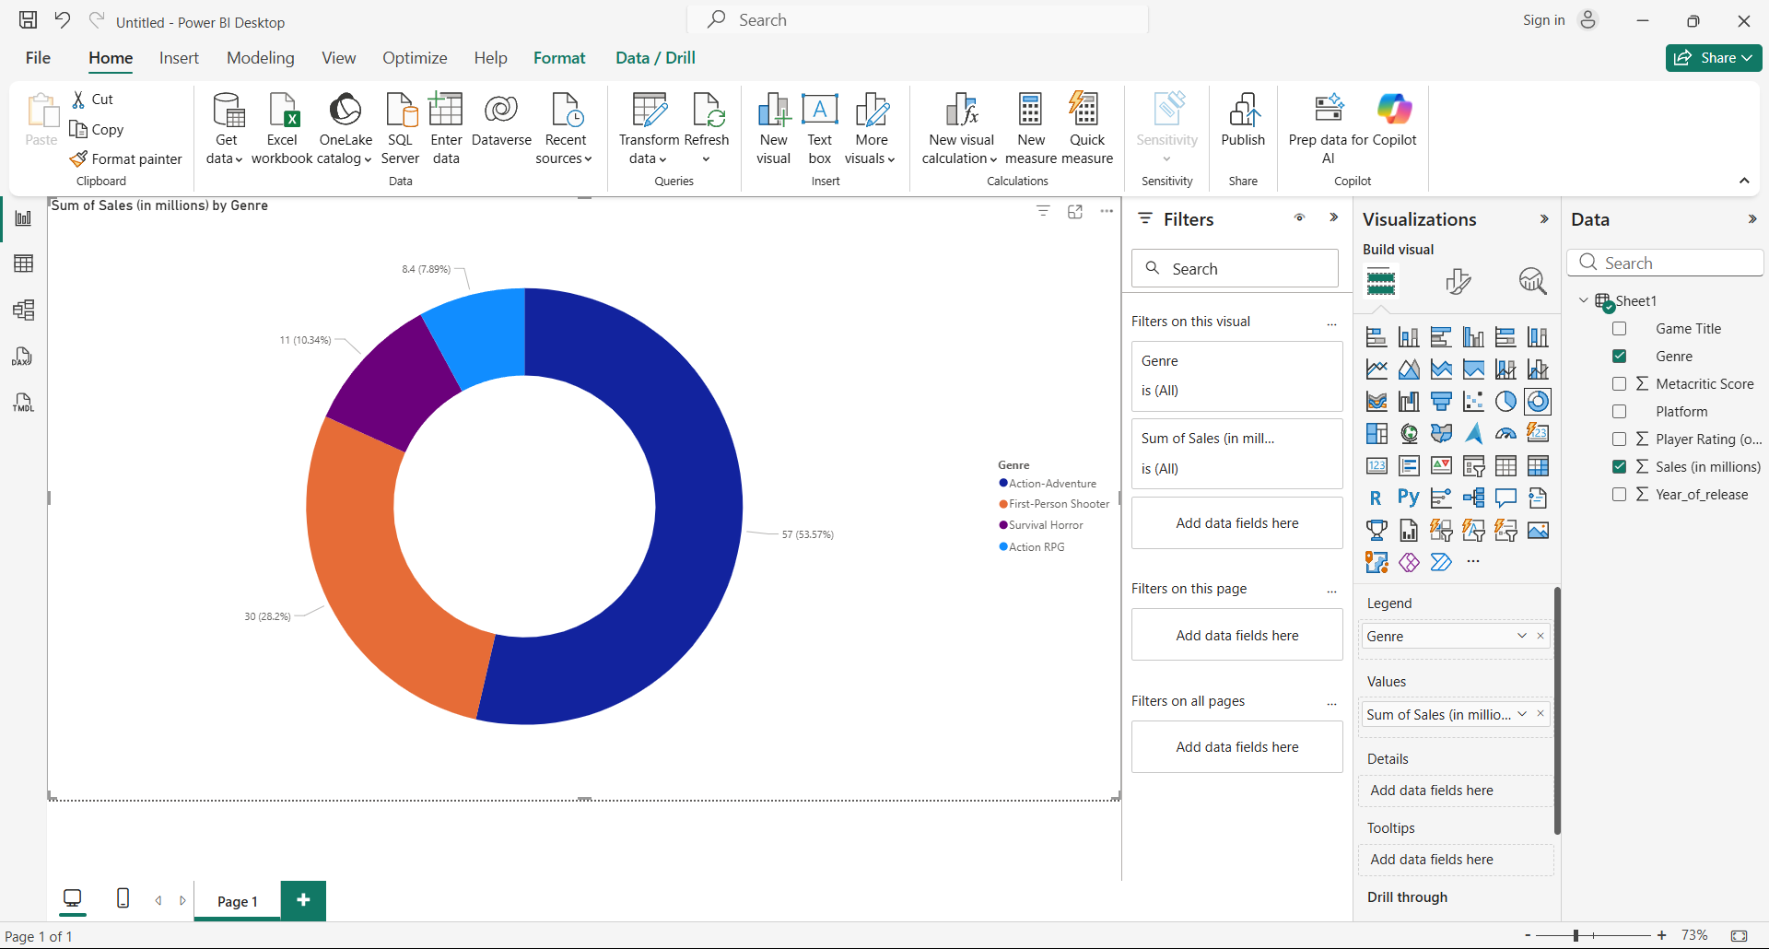
Interpretation:
Steam dominates with RDR2, showing PC’s strong market reach. PS5 performs well with two titles, while PS4 has a smaller share. Platform strategy should favor Steam/PC for broad reach, while PS5 supports multi-title engagement.
Bar Chart: Platform by Sum of Sales
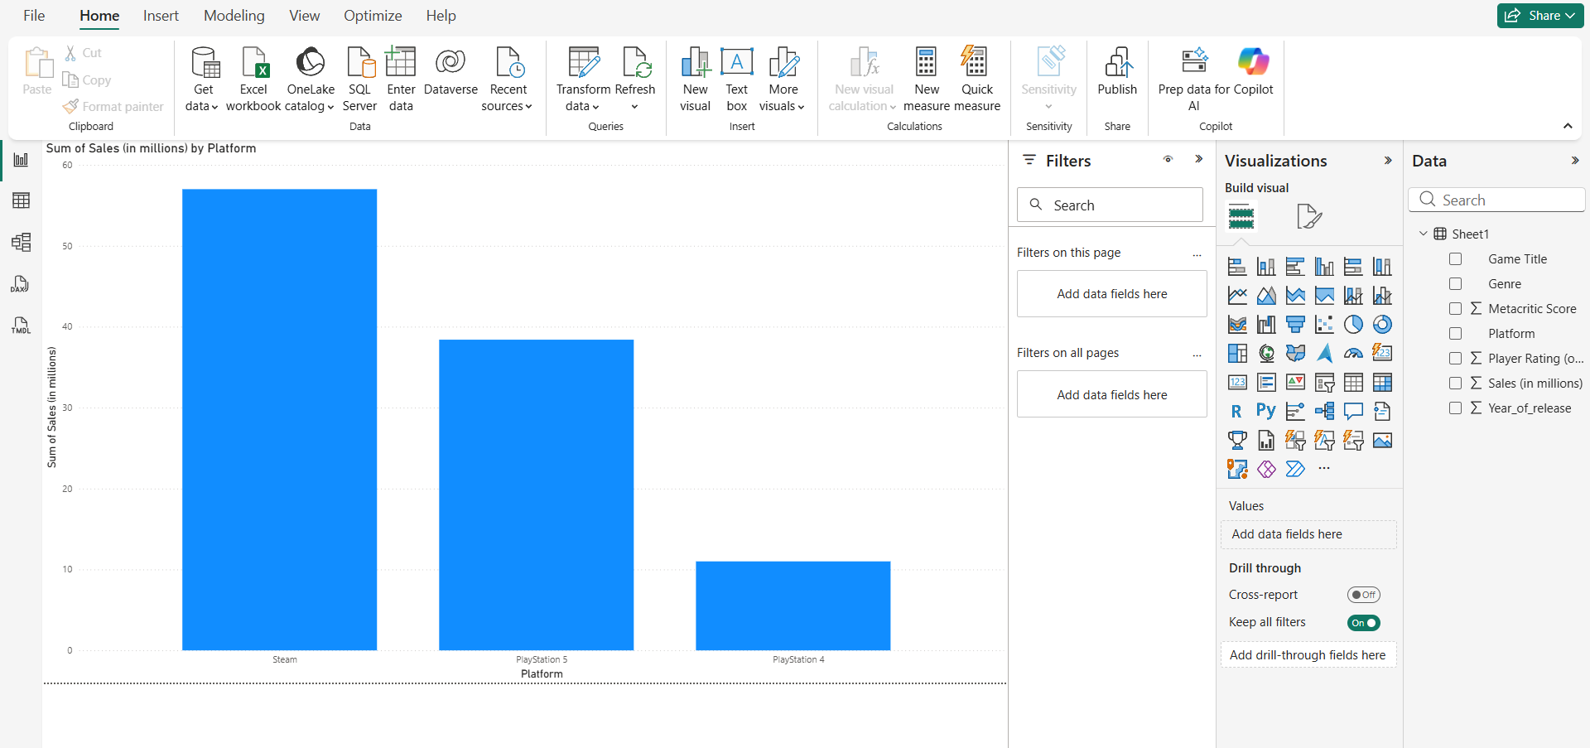
Interpretation:
Steam dominates sales with 57M, largely due to RDR2. PlayStation 5 follows strongly with two titles, while PlayStation 4 has the smallest share. This shows the current strength of PC and next-gen console gaming markets.

Line Chart: Platform by Sum of Sales and Metric Score
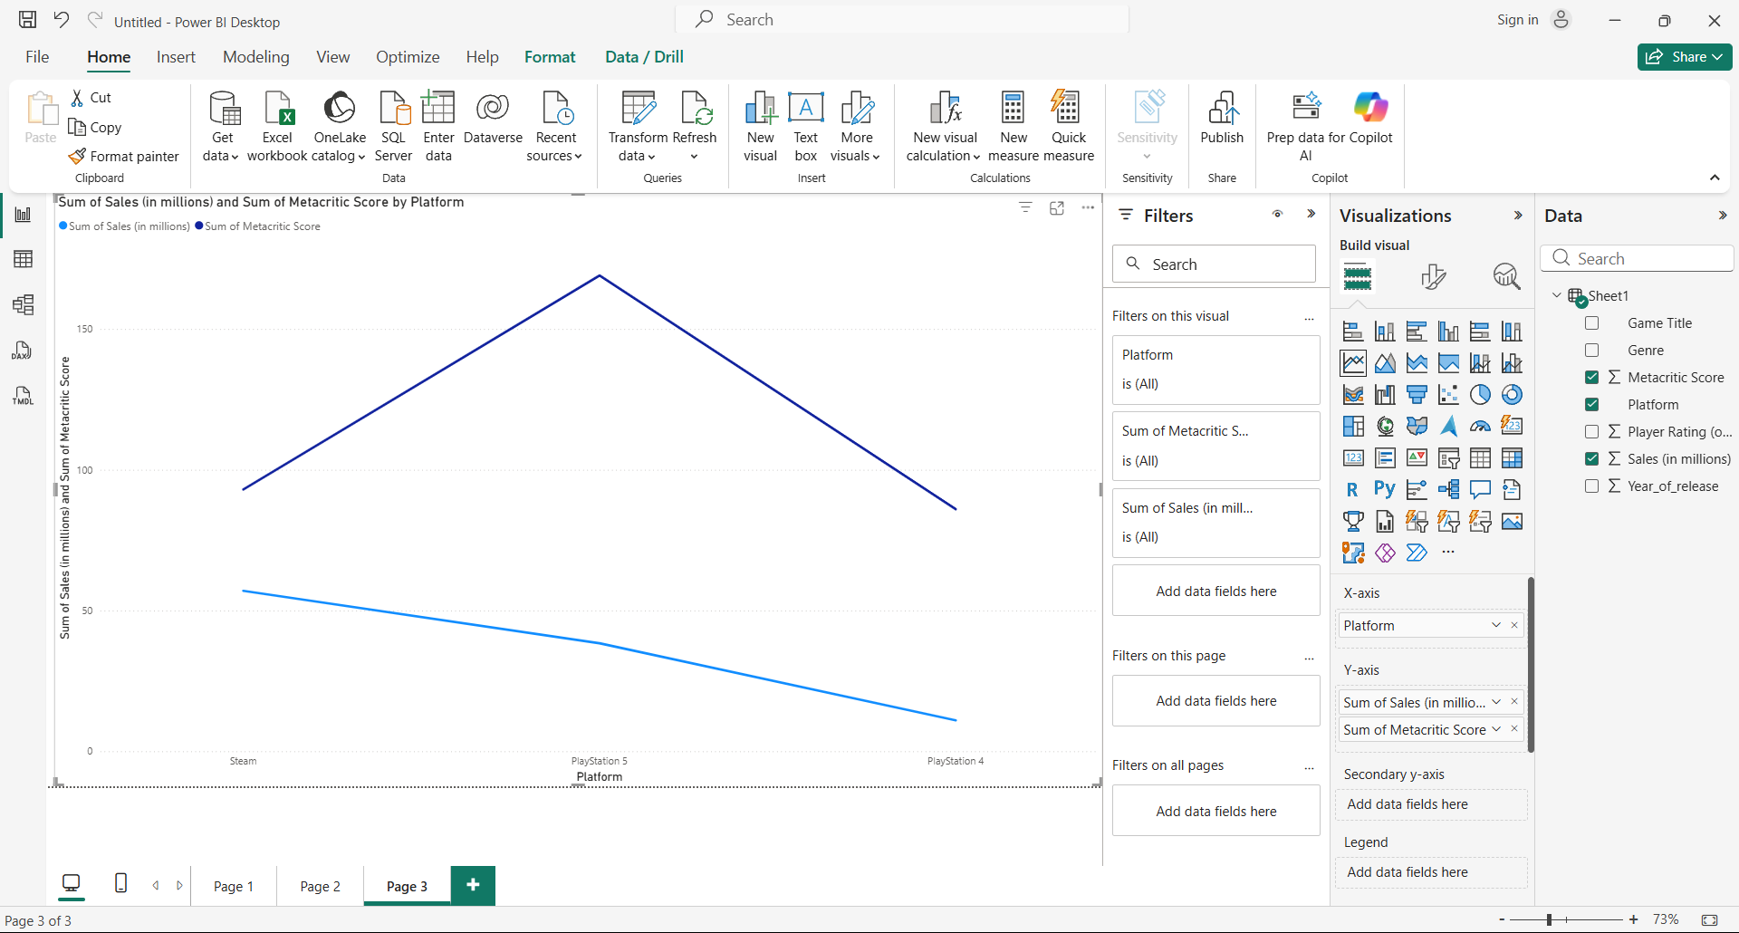
Interpretation:
Steam leads in sales and critic scores, showing strong PC market alignment. PS5 has high sales volume but moderate scores, while PS4 has lower sales but strong critic reception, indicating a quality-over-quantity trend for older platforms.
Funnel Chart: Sales by Sum of Sales
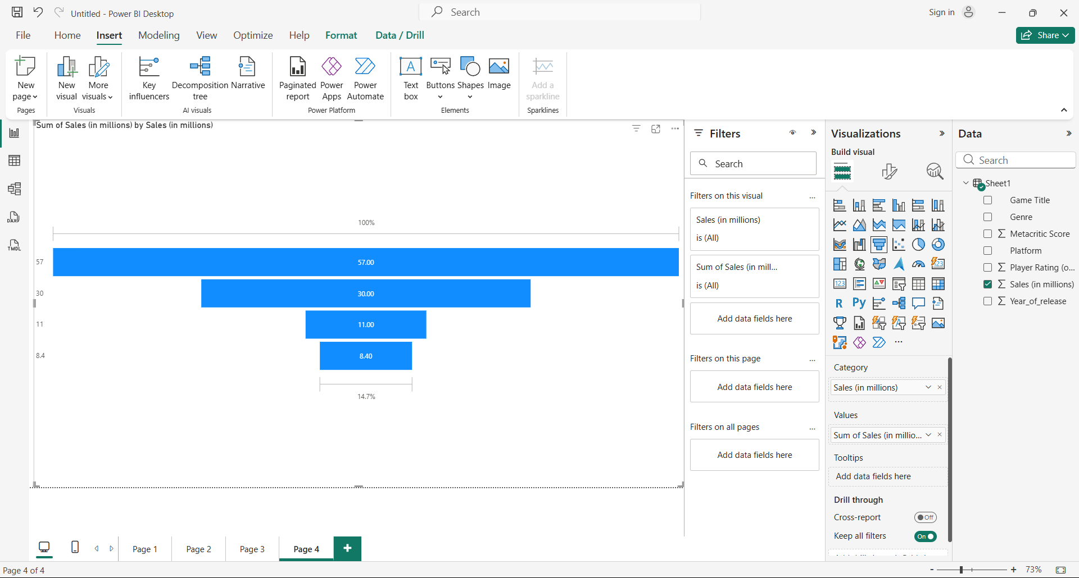
Interpretation:
The funnel chart shows a sharp sales drop-off: RDR2 leads (57M), followed by BO3 (30M), then RE7 (11M), and HFW (8.4M). The top two games dominate market share, while HFW, being the newest, may still be in its growth phase.

Create Clustered Column Chart: To analyse Metric Score by Sum of Sales
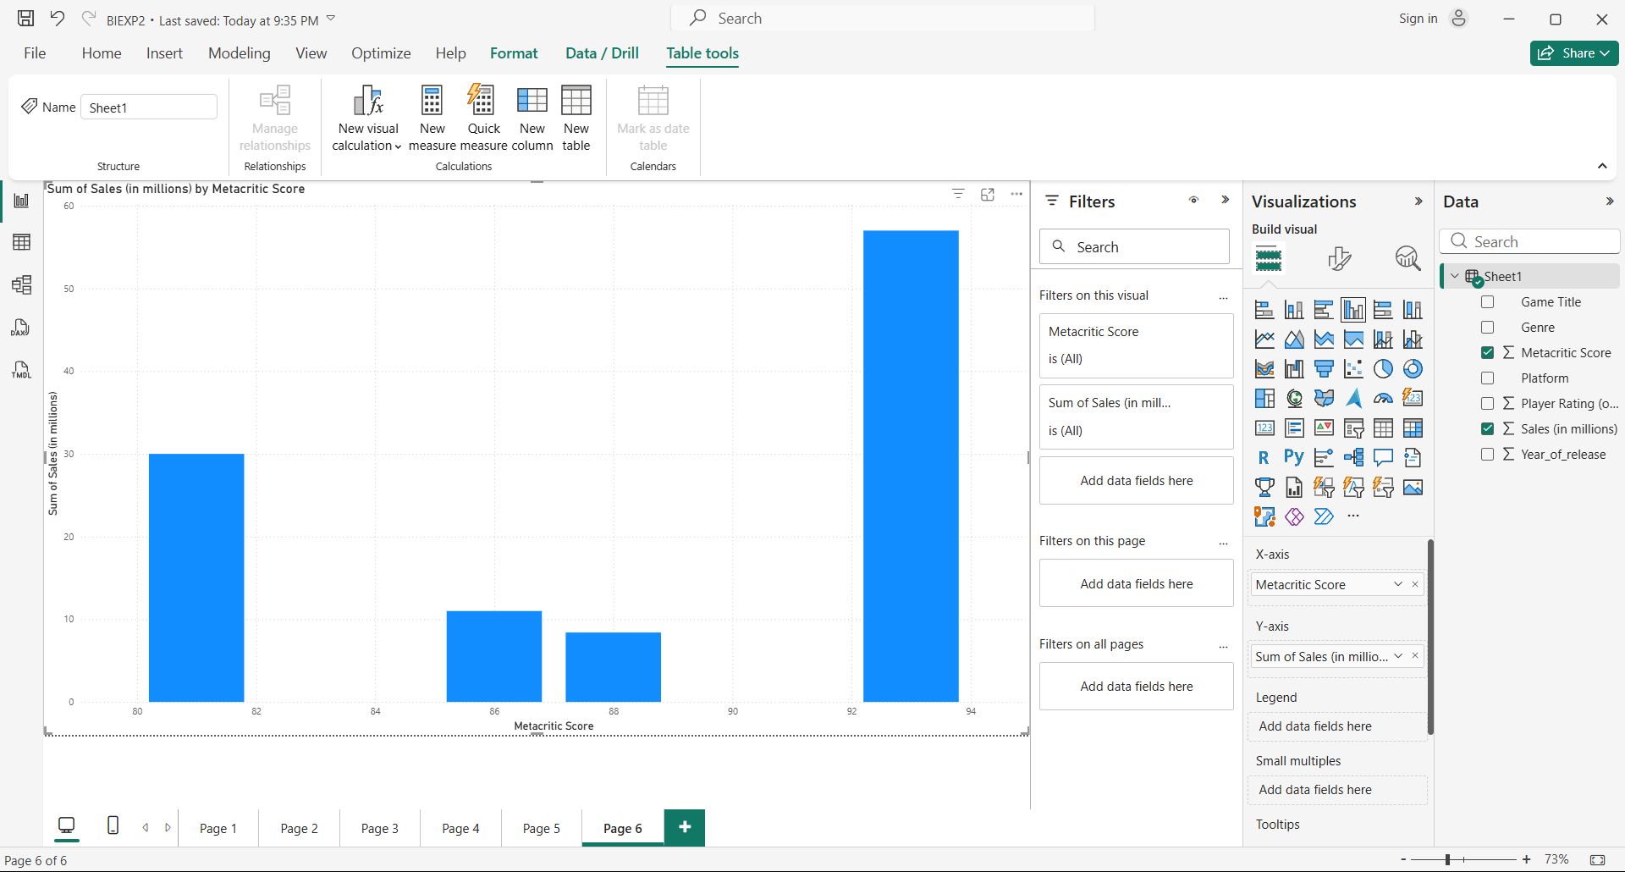
Interpretation:
RDR2 excels in both sales (57M) and ratings (93). HFW scores high (88) but sells less (8.4M), while BO3 sells well (30M) despite average scores (81). High ratings boost sales, but franchise power also drives performance.

Conclusion
This practical exercise effectively demonstrated how Power BI transforms raw data into actionable business intelligence. By visualizing game sales and performance metrics across multiple chart types, we uncovered key insights into sales distribution, platform strength, and the relationship between critic scores and commercial success. The exercise highlights Power BI’s ability to support data-driven decisions in areas such as marketing strategy, platform investment, and title evaluation through intuitive and interactive dashboards

